Communicating Like You Mean It
By Clint Lund

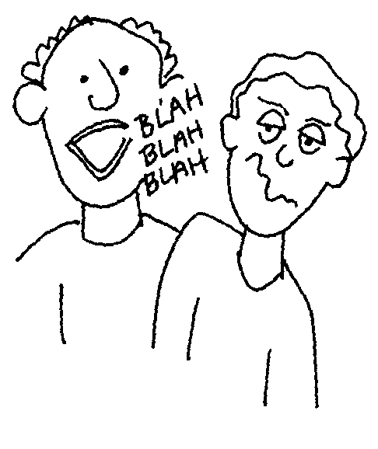
Do you ever have that moment when you’re trying to tell something to a friend, boss, spouse, and you can’t seem to persuade them to understand you? Or have you ever been listening to someone talk and find your mind wandering to the light switch you left on, or the plan you made for the weekend? If you have, congratulations! You are a human.
Communication is the backbone of human interaction. Just like the back bone in your body you cannot do anything without it, and just like that back bone, communication can become strong, weak, or even paralyzed. Those who suffer with communication suffer in relationships too. Those who become strong communicators, truly have powerful relationships with others.
Disclaimer: I am not the end all, be all expert on communications skills. At best I am a novice student, who is trying to improve a skill I see crucial to my life and success. That being said, let’s see what we can learn together through this presentation.
Like you, I never gave much thought to communication let alone knew it was a skill a person could improve upon. My first encounter with learning the basics of communication came as I served a mission for my church. I had to learn how to teach people something new to them. What made it more difficult was, I had to teach them in the Spanish language, something I did not already speak. This was a valuable lesson that taught me the first lesson I want to share with you: listening.
Before serving a mission, any time I heard people speaking in Spanish, it sounded like fast pace gibberish consisting of rrrolling “R’s”. When I began learning Spanish, I had to start to condition my ears to not hear sounds, but listen for individual words within the conversation. I had to try. I had to become less concerned about what I wanted to say and more concerned about what I needed to hear. This required the simple act of being quiet.
To be a good listener you need to release distractions. If you are in a night club trying to listen to a person you are interested in tell you about a problem they are struggling with, it might not be a good idea to sit next to the speakers and snap you fingers to the beat of the song being played. How about telling them what they are trying to tell you sounds important, and you want to hear it? Stand up and walk with them to a more quiet location, then ask them to proceed.

As your dear friend is speaking with you, it may be a good idea to offer a reflection. Reflections are valuable tools that offer feedback meaning. These are moments when you say back to them what you have heard.
There are many ways to do this. One was is a repetitive reflection. Like a parrot, you simply repeat one of the key words from what they just said. It sounds something like this: “I am really excited about my trip to the Grand Canyon at the end of this semester.” You say: “Trip to the Grand Canyon.” This will prompt them to tell you more and helps them see you heard what they said.
Another way to reflect is with a technique known as a simple reflection. These reflections are simple because they are not a long, in-depth analysis of what was said, but rather simple changes of words that add meaning. It may look something like this: “I am really excited about my trip to the Grand Canyon at the end of this semester.” You say: “Being done with the semester and having a fun vacation is on the forefront of your mind.” This will allow them the opportunity to feel validated and elaborate more. Now that’s listening!
When you talk about communication skills, most people think of how you talk rather than how you listen. The idea that communication is all about talking is far from the truth. Listening is just as (if not more) important than how/when we speak. If you learn just one thing from this, I hope it’s that you learn to be a good listener. Those who listen care and we need more people in this world that do.
OK. Let’s talk about talk.
“Talk is cheap” or is it? Talk has started/ended wars, lost/made billions of dollars, and had people fall in/out of love. Those things don’t sound like cheap things to me. Those things sound very important and I would not want to tread lightly around those topics. It would probably be smart to think about what we say and how it is said.
Sometimes (most times) we need to say something very important. We need to tell a person they have offended us and we want them to apologize. We need to ask a boss for a well deserved raise. We need to invite that “cutie” in our English class out for some ice cream. Where do we start and how do we do it? How will we ensure what we say isn’t laced with negative emotions that send the wrong message? Nothing could be worse than to end up in a fight, get fired, or rejected from the “person of our dreams” in that English class.
Apathy vs. Empathy. What is apathy? Google defines apathy as “Lack of interest, enthusiasm, or concern.” How horrible would it feel to be telling a person about something important like a job you had just been laid off from and hear “well, if you had listen to me and got on where I work now, you’d still have a job.” It doesn’t sound like that person cares about how sad you are but rather how right they were. No one wants to talk with someone like that.
We want to talk with our empathetic friend. According to Google empathy is “the ability to understand and share the feelings of another.” When a friend confides in us about the loss of a job, we will tell them “ah. I am so sorry. You worked really hard at that job. This must be very difficult for you.” Let’s proceed to learn about how to employ empathy in what we need to say.
You have heard of the Golden rule: “Treat others the way you want to be treated.” Let’s take it one step further and move from gold to platinum. The platinum rule advocates we don’t treat people how we want to be treated, but rather how they want to be treated. Simply stated: “Treat others the way they want to be treated.”
From the book “Crucial Conversations: tools for talking when the stakes are high.” We learn “When it comes to risky, controversial, and emotional conversations, skilled people find a way to get all relevant information (for themselves and others) out into the open."
Learn to Name Your Emotions. Animals (including humans) have two basic reactions to danger. They are “fight or flight.” When your back is against the wall, you will either confront the adversary or run from it. Placing yourself in the situation of control means you will have to call it how you see it. “Oh! This is anger I’m feeling.” Accept your emotions. Take it for what it is.
Respond Rather than React. So often we allow our emotions to control us rather than the other way around. Emotions are a natural part of life. You’re bound to feel joy, sadness, pride, shame, sorrow and happiness in your life. The trick is to learn how to place a dam in between the river of feeling and the waterfall that is our big mouth. The material to build this dam is discipline, sound thought, and practice.

Always be Respectful. Someone said something deliberately hurtful to you. They called you a cruel insult in front a room full of friends. Your face turns red and your heart begins beating like you just spent the last hour walking up a mountain. You want to reach out and pound this creep into the ground or run 1000 miles from where you are.
What do you do? Stop! Let’s think for just a second. What did this person expect to accomplish by insulting me? He/she wanted to start an argument or get me to walk away humiliated. Do I really want them to win? NO!
After I have thought things out for a second and while all eyes are on me I coolly formulate a plan. I smile and say “I’m sorry you feel that way. I’d like to resolve this and not ruin the night for any of our friends here by having an argument. I’m sure we can be reasonable about this. Let’s go somewhere in private and talk this out. ” This tactic shows you are strong enough to stand your ground, caring enough to be considerate of your friends, but mostly you are in control of the situation, not them. You just took the home field advantage and put 50 points on the scoreboard. Folks this gave may as well be over.
This same process of damn building and controlled verbal flow can be used in every situation. Think about what you would like to accomplish in your conversations. Plan out how it should sound. Then carefully and respectfully have that conversation.

Sources:
- Dave Ellis: Becoming a Master Student
- William R. Miller and Stephen Rollnick: Motivational Interviewing
- Carl Rogers: On becoming a Better Person
- Patterson, Kerry; Grenny, Jospeh; McMillan, Ron; Shwartz, Al. McGraw-Hill 2002. Crucial Conversations: tools for talking when the stakes are high

