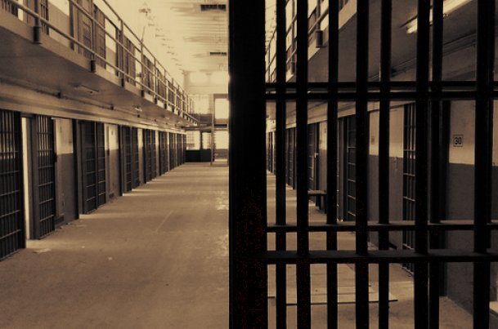

Corrections: Turning the Tide

The United States boasts the largest inmate population (now over 2.3 million) in the world—five times that of Great Britain, nine times more than Germany and 12 times more than Japan (Too Many Laws, Too Many Prisoners). To put this into further perspective, the US contains only 5 percent of the world’s population yet houses a quarter of its incarcerated. One in every 100 American adults currently resides behind bars (Gelb). In Utah one in every 64 adults is under some form of correctional control whether on probation, parole, or in a prison or jail cell throughout the state (Pew Center on the States 2).

Incarceration is costly; reducing recidivism helps
Over the past 30 years incarceration has been the crime-fighting weapon of choice, and the United States has created the largest prison system in the world to accommodate our ever-growing offender population. The states’ cumulative cost of corrections is more than $50 billion a year. Ninety percent of that money is spent keeping prisoners locked up, and parolee recidivism accounts for one-third of prison admissions (Gelb) (St. Gerard). The high cost of incarceration and many states’ constant battle to balance budgets has lead many policy makers to reevaluate the traditional corrections system (Gelb).
It is time for corrections departments across the nation to shift focus from heavy-handed punishment to education and rehabilitation of offenders in an effort to reduce recidivism, minimize victimization, and keep correctional spending in check.

Education and treatment programs: Readying offenders for Reentry
Utah is one of many states taking steps to reduce recidivism through education and programming. The Division of Programming at the Utah Department of Corrections was created in April of 2007 in an attempt to promote offender success upon reentry into the community. As soon as a convicted offender enters the correctional system their needs are assessed, and an Offender Management Plan is created (Utah Department of Corrections). This plan contains a detailed outline of education, treatment, and vocational training the offender is encouraged to complete during the course of their supervision.
These plans, also referred to as MAPs are specific to the needs and situation of each offender and may include sex offender therapy, substance abuse treatment, cognitive training, and, possibly, employment within the prison (Utah Department of Corrections). Also, traditional education is a focal point in Utah’s prison system.
About 50 percent of high school dropouts will be incarcerated at some point in their lives, and it is estimated that 75 percent of inmates lack a high school education (Kaiser) (Gonnerman and Brown). Inmates who will be serving a long enough sentence to complete adult high school and obtain a diploma are encouraged to do so. Those with shorter sentences are encouraged to complete the GED (Utah Department of Corrections).
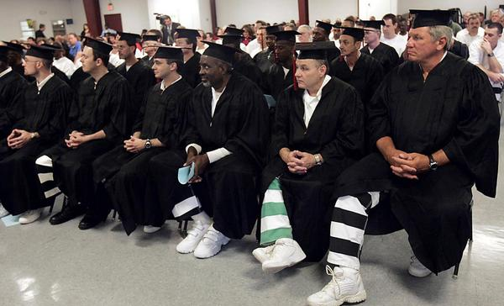
Post-secondary education opportunities are offered as well, however, in 2010 the state moved from offering degree-base education to vocational certificates citing that this change would “allow offenders to find employment opportunities more easily once they are released from prison” (Utah Department of Corrections) (Walsh).

Costly programming saves taxpayers in the long run
Running such an intensive system for society’s misbehaved certainly sounds costly, and it is. In 2008, in the midst of the recession, Utah spent $330 million on corrections (Pew Center on the States 2). In one year that figure jumped to $386 million—8 percent of the general fund spent on 1.6 percent of the population (Henry J Kaiser Family Foundation).
Approximately 57 percent of the correctional budget is spent on programs and operations (Walsh). It stands to reason that simply warehousing inmates in their cells for their prescribed sentences, rather than employing resources to treat and educate them would save taxpayers millions. However, one startling fact remains: Ninety-five percent of inmates will someday be released from prison, and within 3 years, half will be convicted of a new crime (Lawrence) (Gonnerman and Brown). This means that they will continue to burden the ever-expanding Corrections System, and create an entirely new population of victims unless they can be reformed.
Minnesota Commissioner of Corrections Tom Roy said it well when he explained that catching and prosecuting a criminal is important work, but if the system wastes the prescribed sentence, “and it’s the same guy walking out the [prison] doors with the same criminal thinking, we’ve failed our mission” (Pew Center on the States).
Fifty-four percent of inmates released from Utah’s prison system in 2004, were back behind bars by 2007 (Pew Center on the States). The hope is that by implementing education and programming within the prison system, we will save money in the long run by reducing inmate population and minimize victimization by inciting change in those who will eventually walk out the gate and onto our streets.
This hope is not unfounded. There is a lot of research that supports correctional education and programming as the cost-effective way to manage those under correctional control because of its affect on the rate of recidivism. In the report by Audrey Bazos and Jessica Hausman, Correctional Education as a Crime Control, it states $1 million spent on correctional education prevents 600 new crimes, while the same amount invested in incarceration prevents only 350 crimes (Kaiser).
According to a 2003 University of Utah study, the rate of return to prison fell by 10 percent for inmates who participated in the education program (Stewart). Bazos and Hausman reported that Wisconsin experienced a 20 percent reduction in recidivism in offenders who completed an educational program. Their report showed that the true effect of correctional education falls between a 10 and 20 percent reduction in recidivism, and that even a six percent decrease would break even with the cost of the programs. The study indicates that $1 million spent on correctional education would yield $1.6 million in savings due to recidivism reduction (Kaiser).

Correctional programming is not without its critics
Despite overwhelming evidence in favor of correctional programming and education, many citizens are unhappy at the prospect of their tax-dollars paying for the educations of those who don’t play well with others. Jeffrey Galli, corrections education specialist at the Utah State Office of Education, says he gets plenty of mail expressing this very sentiment.
"People say 'Why are we wasting money on these scum?' " Galli said. "But you've got to see the value of education. Would you rather this person be paroled in better condition than when we got them? They don't just get better on their own. We're in the corrections business here" (Stewart).
Still, Galli says he understands the concern “as low-income residents with no criminal background are unable to afford college degrees, but prisoners get a subsidized education” (Stewart). Inmates in the college or vocational training program generally pay only $60 a semester—the equivalent of which would cost the average citizen at least $1200.00 (Stewart) (Collegestats.org).
The case of correctional education is put under further scrutiny by a report released in April 2011 by The Pew Center on the States which suggests that steps to reducing recidivism, including programming and education, are not doing as well as other reports indicate. Utah’s recidivism rate dropped from 65.8 percent between 1999 and 2002 to 53.7 percent between 2004 and 2007 (Pew Center on the States). At first glance this seems to be a good return on correctional spending; however, Adam Gelb, director of The Pew Center’s Public Safety Performance Project, argues that reduction in recidivism rates is more a reflection on how states are managing parolees than an indication of the successes of programs and education offered to offenders (Pew Center on the States).
Gelb insists that increasing our reliance on probation and parole programs for non-violent offenders is the real key to reducing recidivism and managing correctional budgets (Crary). Even still, the success of community corrections programs, as they are called, depends on the same treatment, counseling, and educational opportunities as are now being implemented within prison walls.
Gelb’s argument does not discredit the need for programming within the correctional system; he simply has found a way to reduce the cost of offender rehabilitation by suggesting that it can be performed on the outside.

Volunteer programs can make programming affordable within post-recession budgets
As compelling as the evidence for offender programming and education may be, it is possible that, given current economic circumstances, states cannot afford to run these programs and may resort to releasing hundreds of unreformed inmates before their sentences are complete (Shapiro and Wizner). It is arguable that much of the rehabilitation process could be performed outside of prison walls through post release programs like probation and parole systems, as Adam Gelb suggests, but even this may be too costly for some states to manage (Abramsky).
One potential solution for rehabilitation in both prisons and probation/parole agencies is offered by faith-based programs. Faith-based strategies for rehabilitation are “rooted in religious principles and help offenders by introducing moral concepts found in the Bible, the Koran, and other spiritual texts” (Cei). The idea is simple—conforming to religious principle like honesty, non-violence, and service will deter offenders from committing future crimes. The Supreme Court has prohibited states from using public moneys to pay for such programs. They are run voluntarily, and inmates must volunteer to participate.
In 1997, a study of four New York Prisons found that inmates who participated heavily in faith-based programs were far less likely to be re-arrested during their supervised release period—14 percent versus 31 percent (Cei). Even a critic of these programs, Mark Kleiman, author of “Faith-based Fudging,” concedes that “you don't have to believe in faith-healing to think that an intensive 16-month program, with post-release follow-up, run by deeply caring people might be the occasion for some inmates to turn their lives around” (Kleiman). 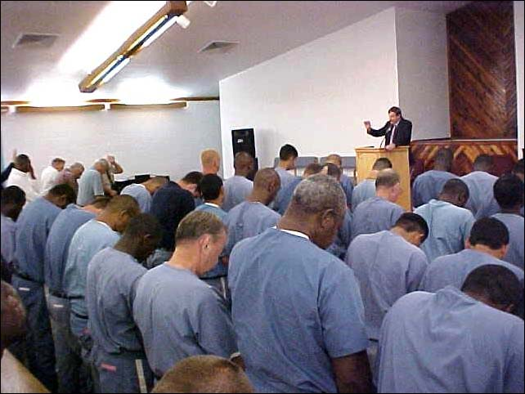
Since 2008 the Virginia Department of Corrections has partnered with Prison Fellowship (PF), an organization that promotes and implements faith-based programs in correctional systems, to create a 20-bed re-entry program for male offenders. The program involves a 12 month prerelease phase followed by a post-release phase in which the offender is offered a volunteer mentor who assists with challenges any offender might face upon re-entry: transportation, housing, employment, and other mandates of his release (Cei).
So far the program has been incredibly successful. None of the participating offenders in the 2008 or 2009 programs recidivated. The department even expanded the program to two other male facilities as well as one female facility. Perhaps the most impressive fact is that programs like these achieve success at almost no cost to the tax-payer, and are at very least a good option for supplementing programming resources within state corrections systems (Cei).

Treat, Educate, Correct—a Belief in Redemption
In a nation where one in every 100 adults is incarcerated (Pew Center on the States), one in every 31 adults is under correctional supervision (Pew Center on the States), and five out of ten inmates released will eventually be convicted of new crimes (Pew Center on the States), we have to incite change within the inmate population for the sake of our communities—very few crimes generate a life sentence.
No matter how closely we manage them, some offenders will recidivate, but we have an obligation to do all we can to rehabilitate the lost and protect the innocent. Nearly every state in the nation is reforming their corrections departments to reflect a belief in redemption through rehabilitation rather than punishment and revenge while desperately trying to keep spending at a minimum. We must find a cost-effective way to turn the tide of the American Prison system before it spirals out of control.

Works Cited
Abramsky, Sasha. "No Rescources, No Results." American Prospect December 2003: 51-53.
Cei, Louis B. "Faith-Based Programs Are Low-Cost Ways to Reduce Recidivism." Corrections Today
August 2010: 48-51.
Collegestats.org. Collegestats.org. 2011. 20 April 2011
<http://collegestats.org/colleges/utah/lowest-instate-tuition>.
Crary, David. "States Urged to Improve Probation, Parole Programs." Portsmouth Herald 2 March
2009.
Gelb, Adam. "Assessment of Spending on Reentry Initiantives, Recidivsm and Corrections." House
Appropriations Committee. Washington DC: FDCH Congressional Testimony, 11 February 2011.
Gonnerman, Jennifer and Ethan Brown. "Slammed." Mother Jones Jul/Aug 2008: 44-46.
Henry J Kaiser Family Foundation. State Health Facts.org. 2009. 20 April 2011
<http://www.statehealthfacts.org/comparetable.jsp?typ=4&ind=33&cat=1&sub=10>.
Kaiser, Michael. "Correctional Education, Because It Works." Corrections Today August 2010: 18-
20.
Kleiman, Mark A.R. "Faith-Based Fudging: How a Bush-promoted Christian prison program fakes
success by massaging data." 5 August 2003. Slate. 20 April 2011 <http://www.slate.com/id/2086617>.
Lawrence, Alison. "Exit Strategy for Parolees." State Legislatures June 2010: 20-22.
Pew Center on the States 2. "Utah." 2 March 2009. 1 in 31: The Long Reach of American Corrections.
13 April 2011 <http://www.pewcenteronthestates.org/uploadedFiles/wwwpewcenteronthestatesorg/Fact_Sheets/PSPP_1in31_factsheet_UT.pdf>.
Pew Center on the States. One in 31: The Long Reach of American Corrections. Washington DC: The
Pew Charitable Trusts, 2009.
—. State of Recidivism: The Revolving Door of America's Prisons. Washington, DC: The Pew
Cheritable Trusts, 2011.
Shapiro, Ian and Stephen Wizner. "Better ways to end prison overcrowding than just releasing
inmates." 30 June 2011.
St. Gerard, Vanessa. "Utah Program Helps Parolees Remain Free." Corrections Today October 2004: 14.
Stewart, Erin. "Utah Inmates Garner Diplomas." Deseret Morning News 6 June 2005.
"Too Many Laws, Too Many Prisoners." Economist 396 (2010).
Utah Department of Corrections. "Educational Opportunities." 2010. UDC. 20 April 2011
<http://corrections.utah.gov/programs/educational_opportunity.html>.
—. "Programming." 2010. UDC. 18 April 2011
<http://corrections.utah.gov/administration/programming.html>.
Walsh, David H. Budget Recommendations Fiscal Year 2012. 10 December 2010. 18 April 2011
<http://www.utah.gov/governor/docs/FY-2012-Recommendation-Book.pdf>.

